**BCA AI ML**

**2024 - 27**

**WEB TECHNOLOGY FILE**

**NAME – TANISHQ KSHYAP**

**SECTION – IB**

**ROLL NO – 12404406N067**

**PRACTICALS**

1. Create a simple HTML page using basic tags**.**

<!DOCTYPE html>  
<html lang="en">  
<head>  
 <meta charset="UTF-8">  
 <meta name="viewport" content="width=device-width, initial-scale=1.0">  
 <title>Simple HTML Page</title>  
</head>  
<body>  
 <h1>Welcome to My Web Page</h1>  
 <p>This is a simple HTML page created using basic tags by Tanishq Kashyap.</p>  
</body>  
</html>

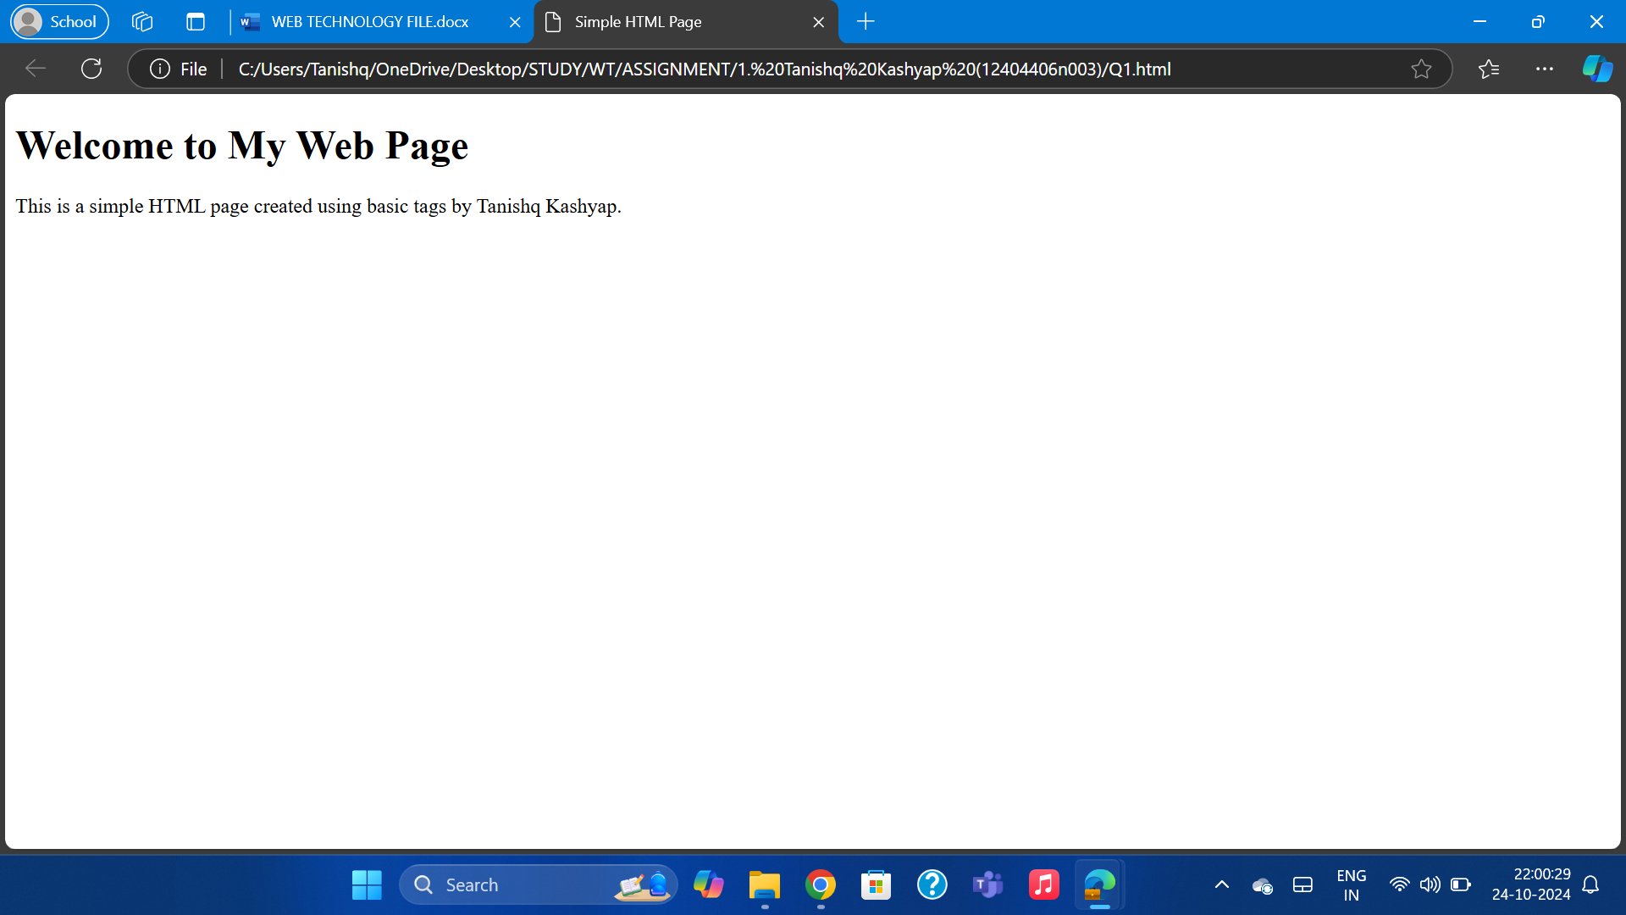

2. Create a web page that displays your name to the screen.

<!DOCTYPE html>  
<html lang="en">  
<head>  
 <meta charset="UTF-8">  
 <meta name="viewport" content="width=device-width, initial-scale=1.0">  
 <title>MY NAME</title>  
</head>  
<body>  
 <h1>TANISHQ KASHYAP (BCA AI ML) </h1>  
</body>  
</html>

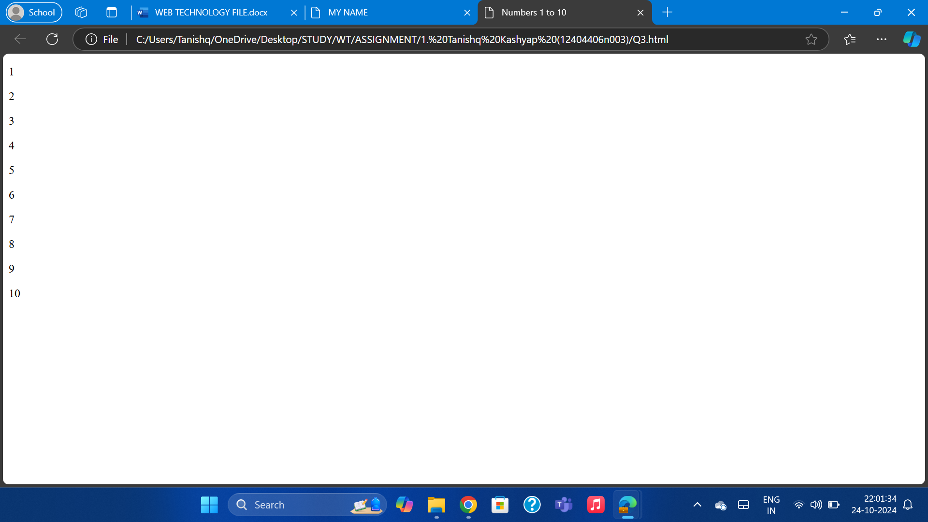

3. Create a web page and show the output from 1 to 10 in separate lines.<!DOCTYPE html>  
<html lang="en">  
<head>  
 <meta charset="UTF-8">  
 <meta name="viewport" content="width=device-width, initial-scale=1.0">  
 <title>Numbers 1 to 10</title>  
</head>  
<body>  
 <p>1</p>  
 <p>2</p>  
 <p>3</p>  
 <p>4</p>  
 <p>5</p>  
 <p>6</p>  
 <p>7</p>  
 <p>8</p>  
 <p>9</p>  
 <p>10</p>  
</body>

</html>

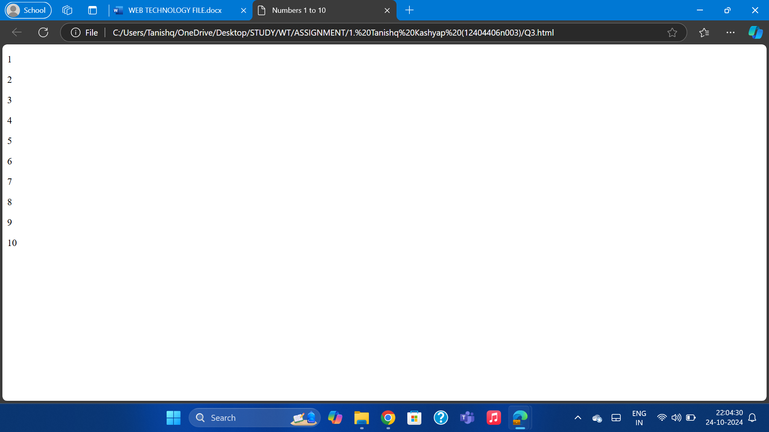

4. Create a web page and show the output from 1 to 10 in separate lines, each number being in different colour.

<!DOCTYPE html>  
<html lang="en">  
<head>  
 <meta charset="UTF-8">  
 <meta name="viewport" content="width=device-width, initial-scale=1.0">  
 <title>Colored Numbers 1 to 10</title>  
</head>  
<body>  
 <p style="color: red;">1</p>  
 <p style="color: blue;">2</p>  
 <p style="color: green;">3</p>  
 <p style="color: orange;">4</p>  
 <p style="color: purple;">5</p>  
 <p style="color: brown;">6</p>  
 <p style="color: pink;">7</p>  
 <p style="color: yellow;">8</p>  
 <p style="color: teal;">9</p>  
 <p style="color: violet;">10</p>  
</body>  
</html>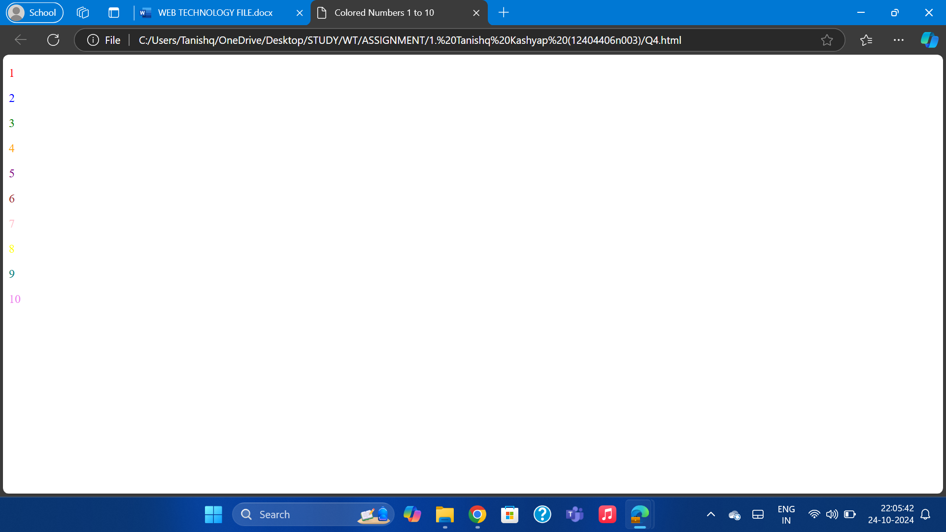

5. How do I make a picture as a background on my web pages?

<html>  
<head>  
<title> Student Information </title>  
</head>  
<body style="background-color:powderblue;">  
<h3 style="color:Tomato;"> </h3>  
<img src= "C:\Users\Tanishq\OneDrive\Desktop ">  
</body>  
</html>



6. Create a web page to print a paragraph with 4-5 sentences, each sentence shall have a different font.

<!DOCTYPE html>  
<html lang="en">  
<head>  
 <meta charset="UTF-8">  
 <meta name="viewport" content="width=device-width, initial-scale=1.0">  
 <title>Paragraph with Different Fonts</title>  
 <style>  
 .font1 { font-family: Arial, sans-serif; }  
 .font2 { font-family: 'Times New Roman', Times, serif; }  
 .font3 { font-family: 'Courier New', Courier, monospace; }  
 .font4 { font-family: 'Georgia', serif; }  
 </style>  
</head>  
<body>  
<p class="font1">MY NAME IS TANISHQ KASHYAP.</p>  
 <p class="font2">MY NAME IS TANISHQ KASHYAP.</p>  
 <p class="font3">MY NAME IS TANISHQ KASHYAP.</p>  
 <p class="font4">MY NAME IS TANISHQ KASHYAP.</p>  
</body>

</html>  
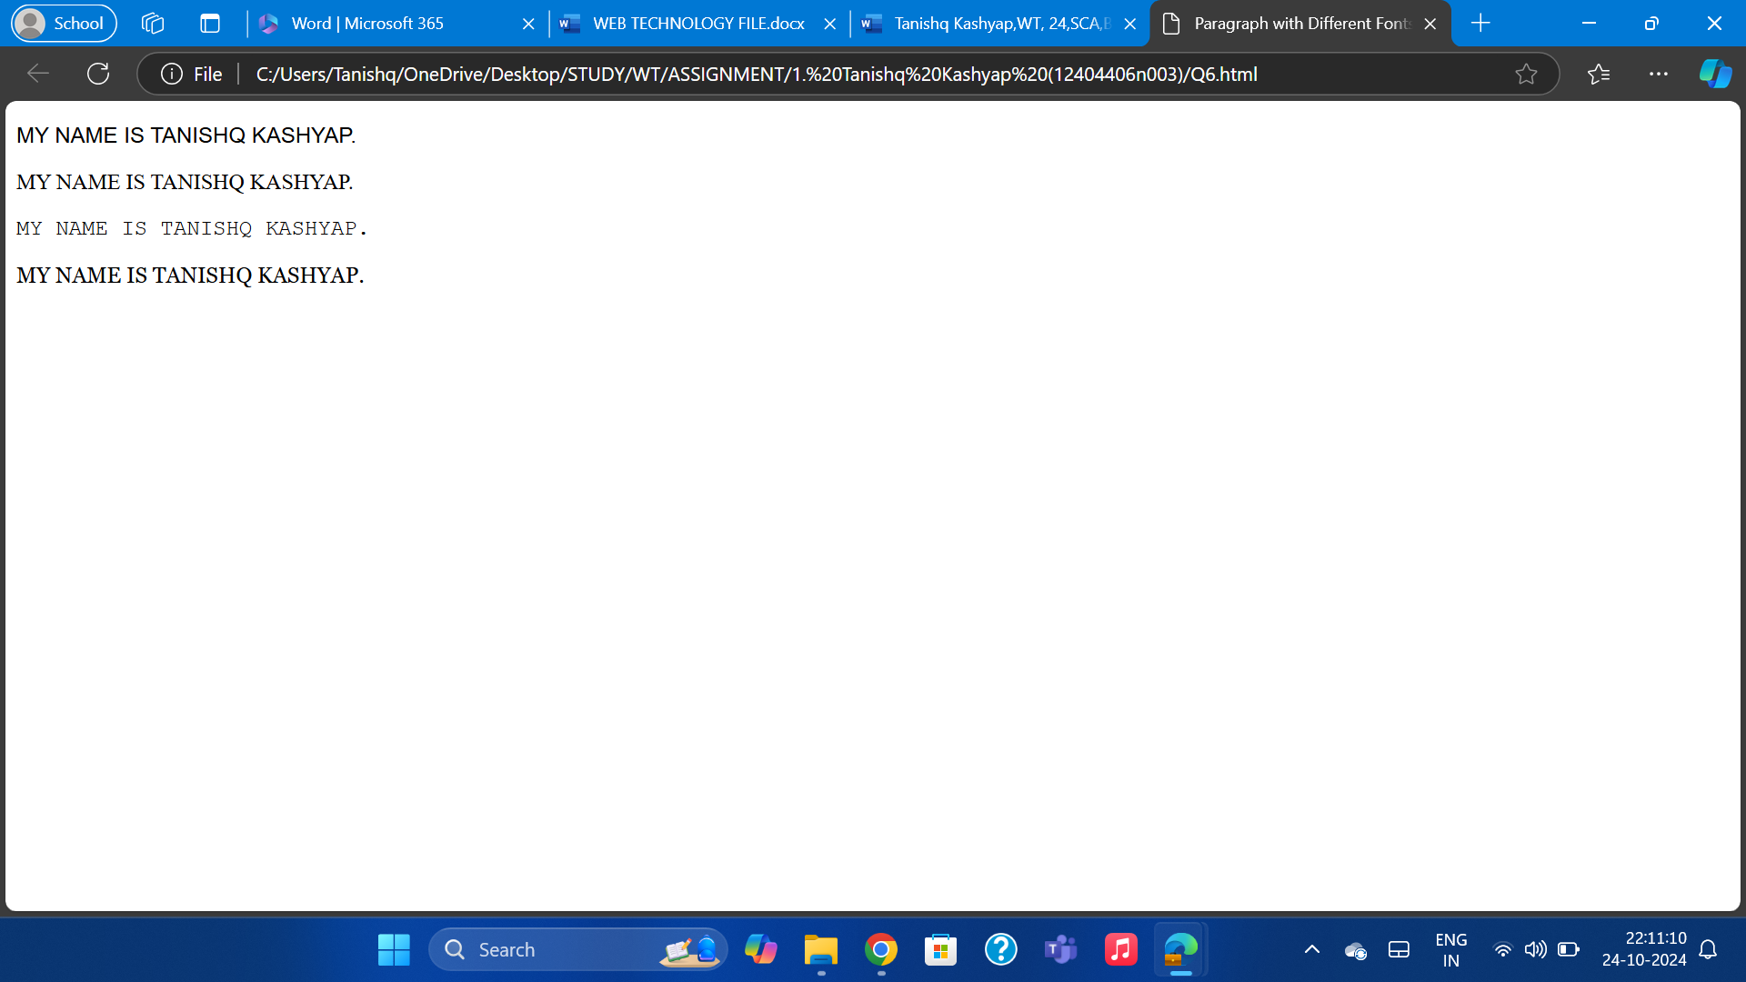

7. Write HTML code to print a paragraph that is description of a book, it shall include the title of the book, its author name; name and title should be underlined and all adjectives shall be bold and Italics.

<!DOCTYPE html>  
<html lang="en">  
<head>  
 <meta charset="UTF-8">  
 <meta name="viewport" content="width=device-width, initial-scale=1.0">  
 <title>Book Description</title>  
</head>  
<body>  
 <p>  
 The book titled <u><b><i>Adventures of Sherlock Holmes</i></b></u> by <u><b><i>Arthur Conan Doyle</i></b></u> is a <b><i>fascinating</i></b> and <b><i>thrilling</i></b> collection of stories. The <b><i>ingenious</i></b> detective solves cases in the most <b><i>unexpected</i></b> ways.  
 </p>  
</body>  
</html>

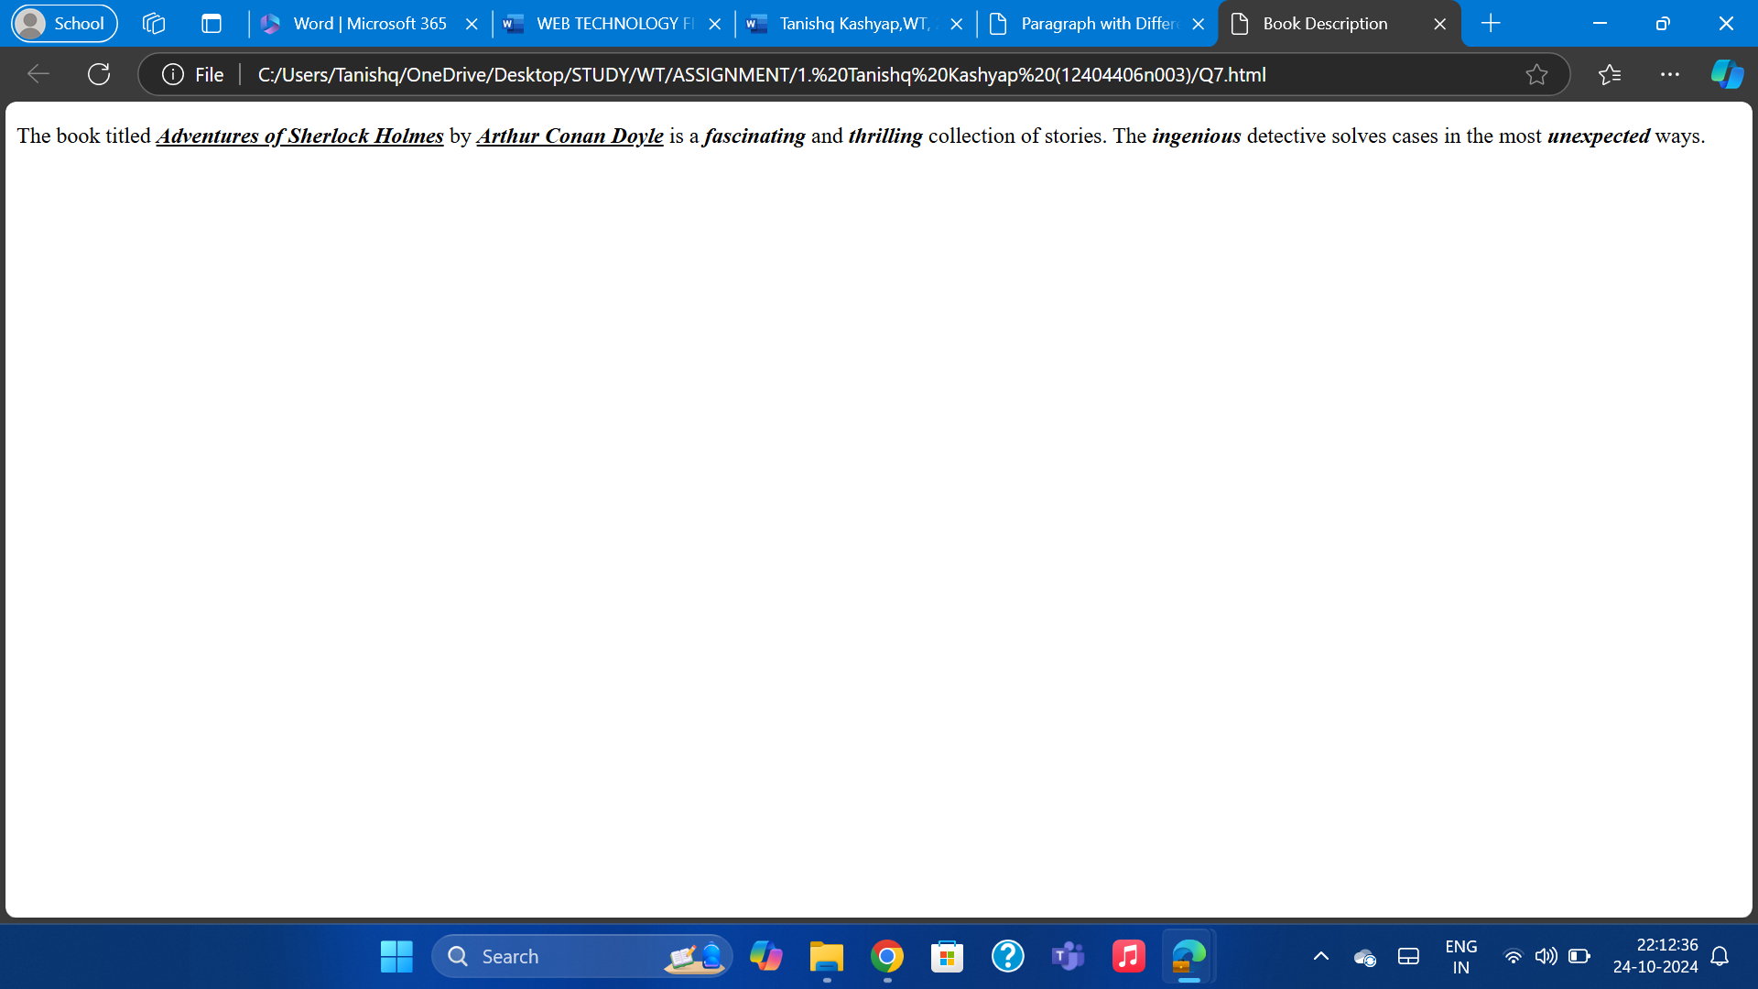

8. Write HTML code to print your name using Heading tag, every letter shall be of different heading size

<!DOCTYPE html>  
<html lang="en">  
<head>  
 <meta charset="UTF-8">  
 <meta name="viewport" content="width=device-width, initial-scale=1.0">  
 <title>Name with Different Heading Sizes</title>  
</head>  
<body>  
 <h1>T</h1>  
 <h2>A</h2>  
 <h3>N</h3>  
 <h4>I</h4>  
 <h5>N</h5>  
 <h6>S</h6>  
 <h6>H</h6>  
 <h5>Q</h5>  
</body>

</html>

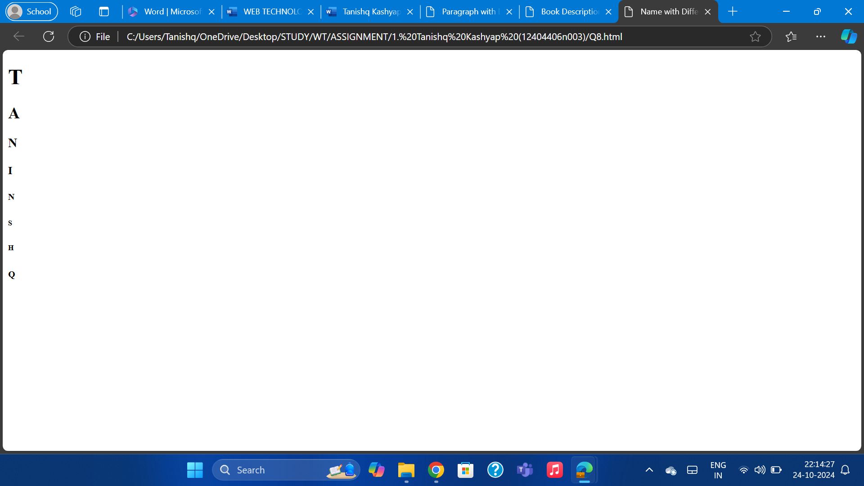

9. Writetum code to print the sequence of numbers 1-20. Each number shall be in different line with number 2 next to it as subscript, an equal sign and the result.

<!DOCTYPE html>  
<html lang="en">  
<head>  
 <meta charset="UTF-8">  
 <meta name="viewport" content="width=device-width, initial-scale=1.0">  
 <title>Numbers Sequence with Subscript</title>  
</head>  
<body>  
 <p>1<sub>2</sub> = 2</p>

<p>2<sub>2</sub> = 4</p>  
 <p>3<sub>2</sub> = 6</p>

<p>4<sub>2</sub> = 8</p>

<p>5<sub>2</sub> = 10</p>

<p>6<sub>2</sub> = 12</p>  
 <p>7<sub>2</sub> = 14</p>  
 <p>8<sub>2</sub> = 16</p>  
 <p>9<sub>2</sub> = 18</p>

<p>10<sub>2</sub> = 20</p>  
 <p>11<sub>2</sub> = 22</p>

<p>12<sub>2</sub> = 24</p>  
 <p>13<sub>2</sub> = 26</p>

<p>14<sub>2</sub> = 28</p>  
 <p>15<sub>2</sub> = 30</p>  
 <p>16<sub>2</sub> = 32</p>

<p>17<sub>2</sub> = 34</p>  
 <p>18<sub>2</sub> = 36</p>

<p>19<sub>2</sub> = 38</p>  
 <p>20<sub>2</sub> = 40</p>  
</body>  
</html>

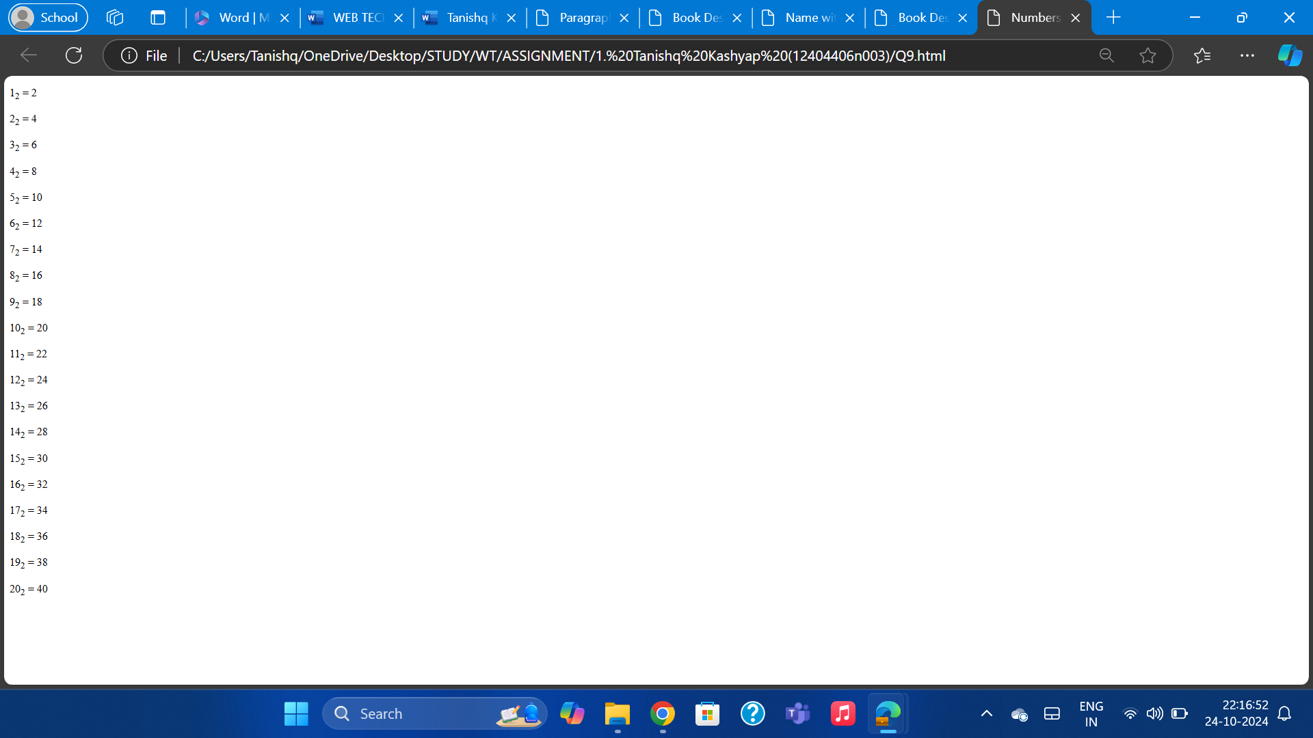

10. Write HTML code to display an image with border of size with width 200, height 200 pixels, leaving space and Vspace of your choice with image hanging in the right side on the screen.

<!DOCTYPE html>

<html lang="en">

<head>

<meta charset="UTF-8">

<meta name="viewport" content="width=device-width, initial-scale=1.0">

<title>Image with Border and Spacing</title>

<style>

.image-container {

text-align: right;

}

.custom-image {

width: 200px;

height: 200px;

border: 5px solid black;

margin-right: 20px; /* Horizontal space */

margin-top: 20px; /* Vertical space */

}

</style>

</head>

<body>

<div class="image-container">

<img src="[bannerimage_1515757127.jpg (680×420) (mbarendezvous.com)](https://www.mbarendezvous.com/images/top-stories-img/bannerimage_1515757127.jpg) alt="Image" class="custom-image">

</div>

</body>

</html>

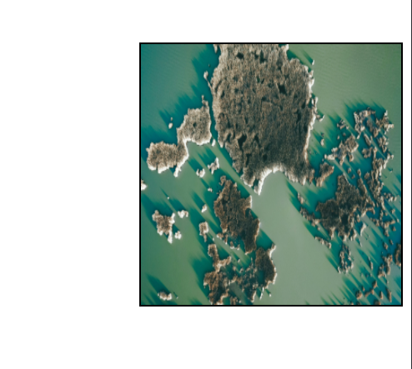

11. Write HTML code to create a web page with heading. The heading shall be displayed at the top-center of the page and the image shall be at the center, just below the heading.

<!DOCTYPE html>

<html lang="en">

<head>

<meta charset="UTF-8">

<meta name="viewport" content="width=device-width, initial-scale=1.0">

<title>Centered Heading and Image</title>

<style>

body {

display: flex;

flex-direction: column;

justify-content: center;

align-items: center;

height: 100vh;

margin: 0;

}

h1 {

text-align: center;

margin-bottom: 20px;

}

img {

max-width: 100%;

height: auto;

}

</style>

</head>

<body>

<h1>Welcome to My Web Page</h1>

<img src="[bannerimage_1515757127.jpg (680×420) (mbarendezvous.com)](https://www.mbarendezvous.com/images/top-stories-img/bannerimage_1515757127.jpg) " alt="Centered Image">

</body>

</html>

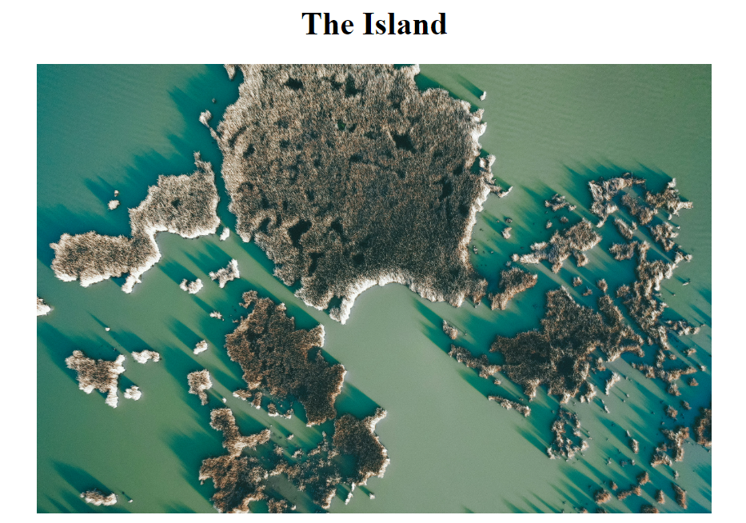

Q12. Write HTML code using Multimedia tags.

<html>

<body> <center>

<h1> multimedia tags: </h1>

<h1>img</h1>

<img src="C:\Users\Tanishqpc\Downloads/xyz.jpg" alt="scenery" height="450" width="450"/>

<h1> audio </h1>

<audio src="C:\Users\tanishqpc\Downloads/Music.mp3" controls/>

<center> </body>

</html>

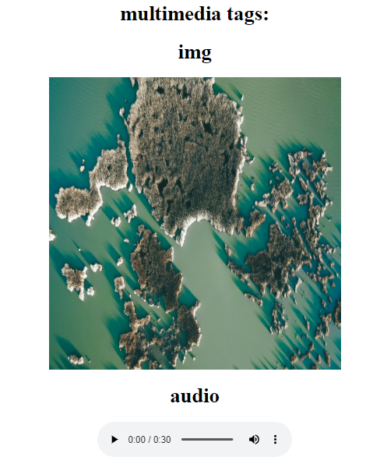

13. Create a Table using Rowspan and Colspan for Student Records

<html>

<head>

<title>Student Record Table</title>

</head>

<body>

<h2>Student Record</h2>

<table border="1" cellpadding="5" cellspacing="0">

<tr>

<th rowspan="2">Name</th>

<th colspan="2">Marks</th>

</tr>

<tr>

<th>Math</th>

<th>Science</th>

</tr>

<tr>

<td>John</td>

<td>85</td>

<td>90</td>

</tr>

<tr>

<td>Alice</td>

<td>78</td>

<td>88</td>

</tr>

</table>

</body>

</html>

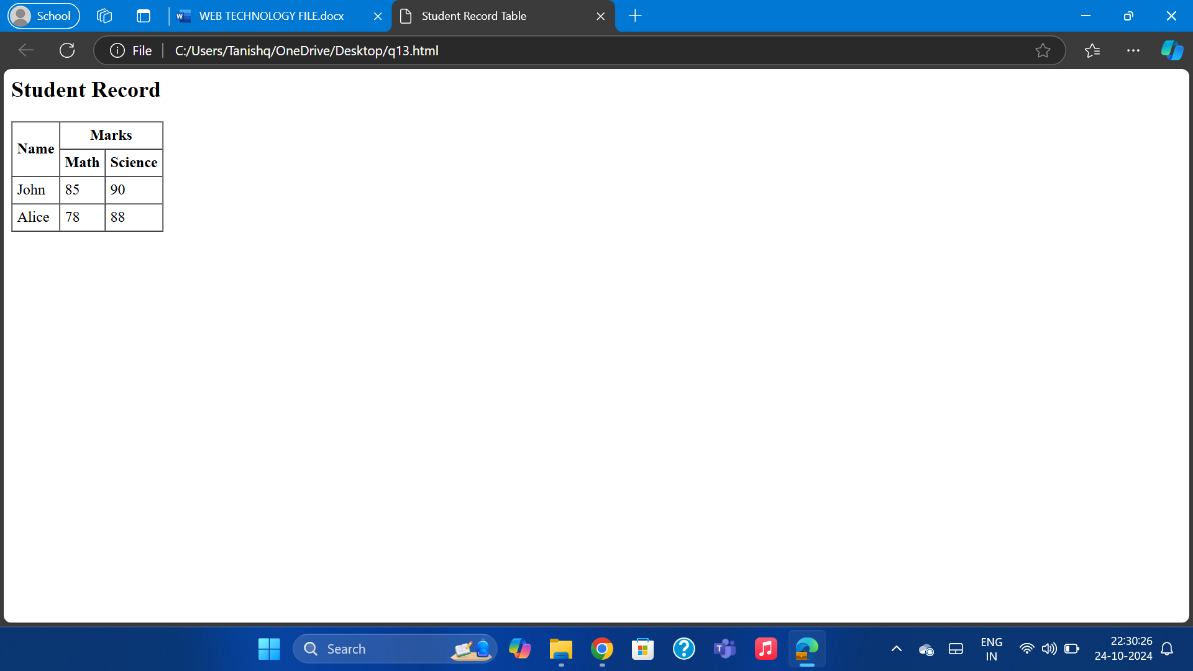

14. Write HTML code using table tag `<table>` and cellpadding and cell spacing as its attributes.

<html>

<head>

<title>Table with Cellpadding and Cellspacing</title>

</head>

<body>

<h2>Table Example</h2>

<table border="1" cellpadding="10" cellspacing="5">

<tr>

<th>Item</th>

<th>Price</th>

</tr>

<tr>

<td>Pen</td>

<td>$1</td>

</tr>

<tr>

<td>Notebook</td>

<td>$3</td>

</tr>

</table>

</body>

</html>

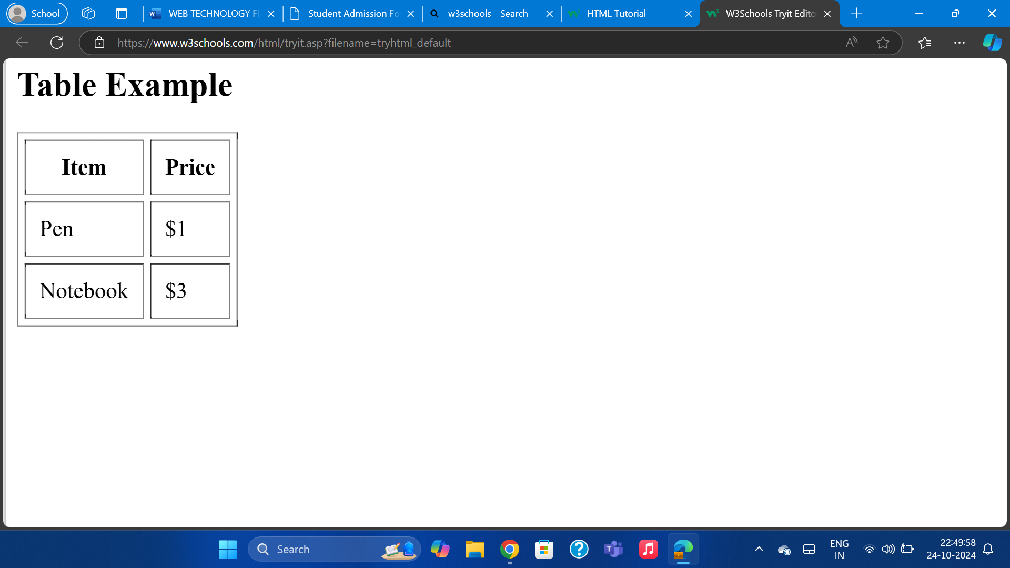

15. Create unordered, ordered and definition Lists taking example of your subjects in MCA IST, IInd and IIIrd Semester.

<html>

<head>

<title>List Example</title>

</head>

<body>

<h2>Ordered List (MCA Semesters)</h2>

<ol>

<li>Semester 1</li>

<li>Semester 2</li>

<li>Semester 3</li>

</ol>

<h2>Unordered List (Subjects)</h2>

<ul>

<li>Data Structures</li>

<li>Operating Systems</li>

<li>Database Management Systems</li>

</ul>

<h2>Definition List</h2>

<dl>

<dt>MCA</dt>

<dd>Master of Computer Applications</dd>

<dt>DBMS</dt>

<dd>Database Management System</dd>

</dl>

</body>

</html>

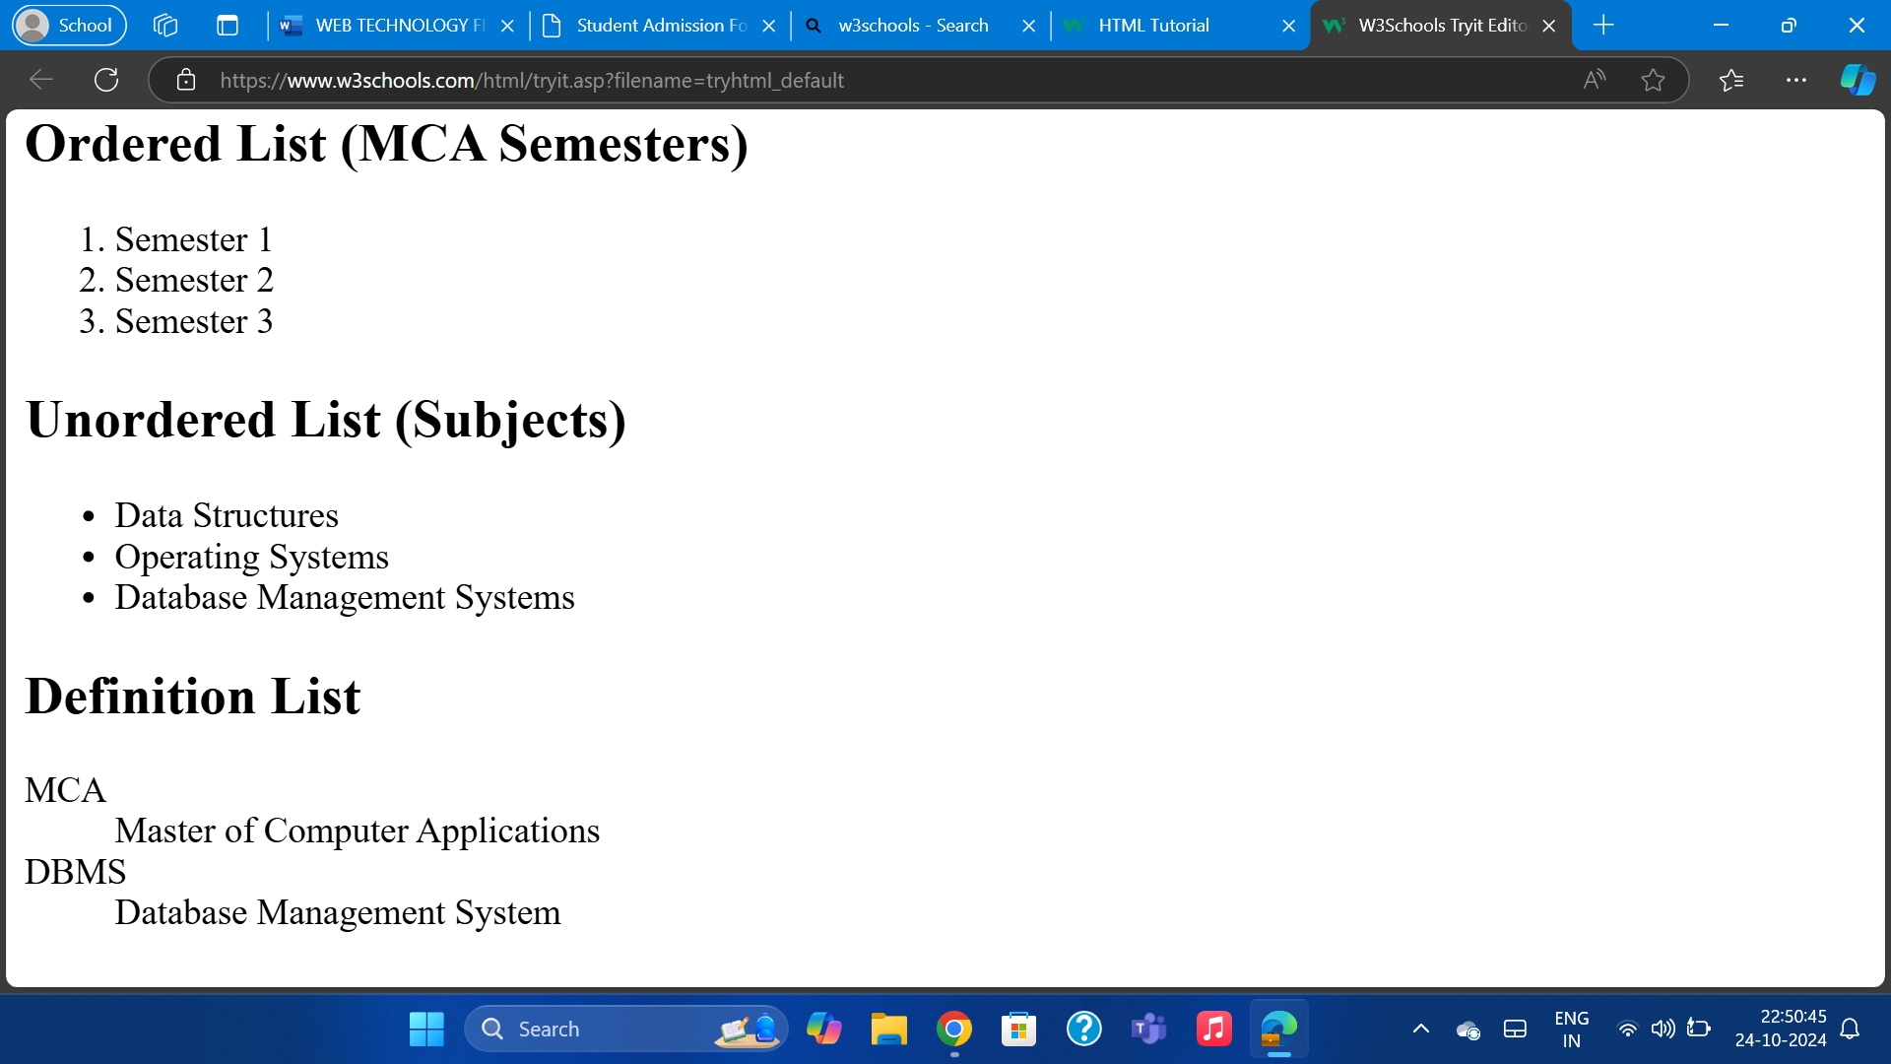

16. Write HTML code using `<frameset>` and `<frame>` tag with all its attributes.

<html>

<head>

<title>Frameset Example</title>

</head>

<frameset cols="50%,50%">

<frame src="page1.html">

<frame src="page2.html">

</frameset>

</html>

17. Write HTML code to design a form in HTML using controls and buttons such as Textbox, Text area, password, submit button, browse button, drop-down menu.

<html>

<head>

<title>HTML Form Example</title>

</head>

<body>

<h2>User Registration Form</h2>

<form>

<label>Username:</label><br>

<input type="text" name="username"><br><br>

<label>Password:</label><br>

<input type="password" name="password"><br><br>

<label>About Yourself:</label><br>

<textarea rows="5" cols="30"></textarea><br><br>

<label>Gender:</label><br>

<input type="radio" name="gender" value="Male"> Male

<input type="radio" name="gender" value="Female"> Female<br><br>

<label>Course:</label><br>

<select name="course">

<option value="mca">MCA</option>

<option value="msc">M.Sc</option>

</select><br><br>

<input type="submit" value="Submit">

<input type="reset" value="Reset">

</form>

</body>

</html>

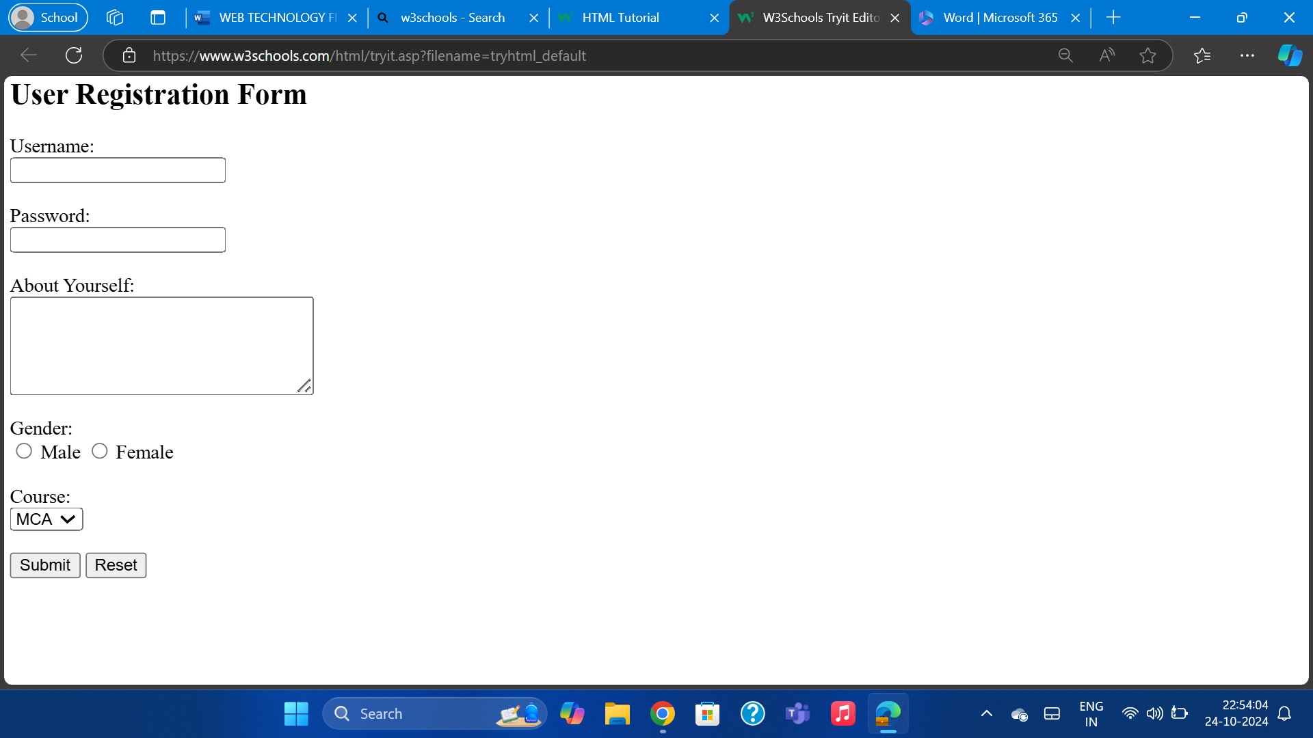

18. Write HTML code to design a Registration Form in HTML.

<html>

<head>

<title>Registration Form</title>

</head>

<body>

<h2>Registration Form</h2>

<form>

<label>Full Name:</label><br>

<input type="text" name="fullname"><br><br>

<label>Email:</label><br>

<input type="email" name="email"><br><br>

<label>Phone Number:</label><br>

<input type="tel" name="phone"><br><br>

<label>Password:</label><br>

<input type="password" name="password"><br><br>

<input type="submit" value="Register">

</form>

</body>

</html>

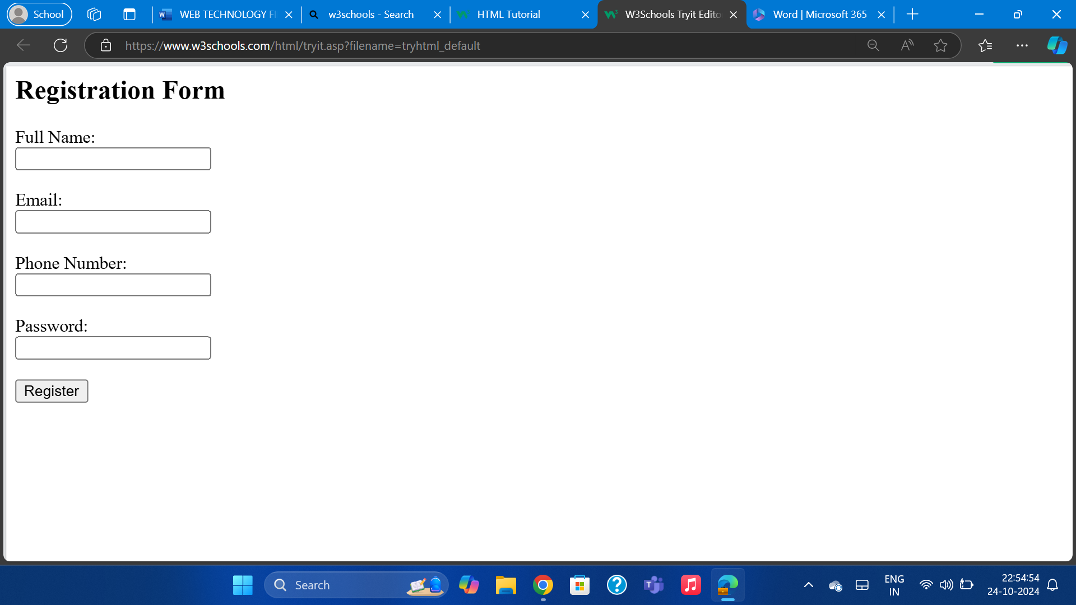

19. Write HTML code to design a student admission Form in HTML.

<html>

<head>

<title>Student Admission Form</title>

</head>

<body>

<h2>Student Admission Form</h2>

<form>

<label>Name:</label><br>

<input type="text" name="name"><br><br>

<label>Date of Birth:</label><br>

<input type="date" name="dob"><br><br>

<label>Email:</label><br>

<input type="email" name="email"><br><br>

<label>Gender:</label><br>

<input type="radio" name="gender" value="Male"> Male

<input type="radio" name="gender" value="Female"> Female<br><br>

<label>Course:</label><br>

<select name="course">

<option value="bsc">B.Sc</option>

<option value="bcom">B.Com</option>

</select><br><br>

<input type="submit" value="Submit">

</form>

</body>

</html>

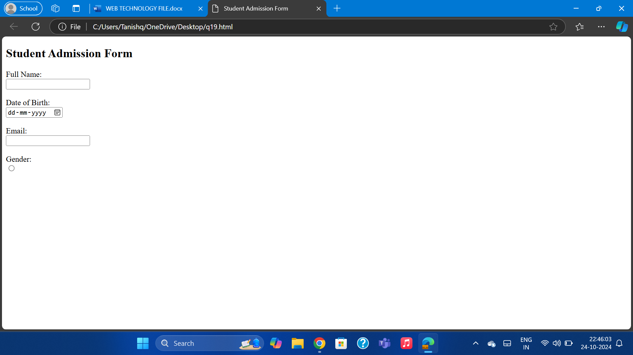

20. Create a proper home page of your own using any components and styles.

<html>

<head>

<title>Home Page</title>

</head>

<body>

<h1 style="text-align: center;">Welcome to My Home Page</h1>

<p>This is the homepage of my personal site.</p>

<nav>

<ul>

<li><a href="#">Home</a></li>

<li><a href="#">About</a></li>

<li><a href="#">Services</a></li>

<li><a href="#">Contact</a></li>

</ul>

</nav>

<footer>

<p>Copyright © 2024. All Rights Reserved.</p>

</footer>

</body>

</html>

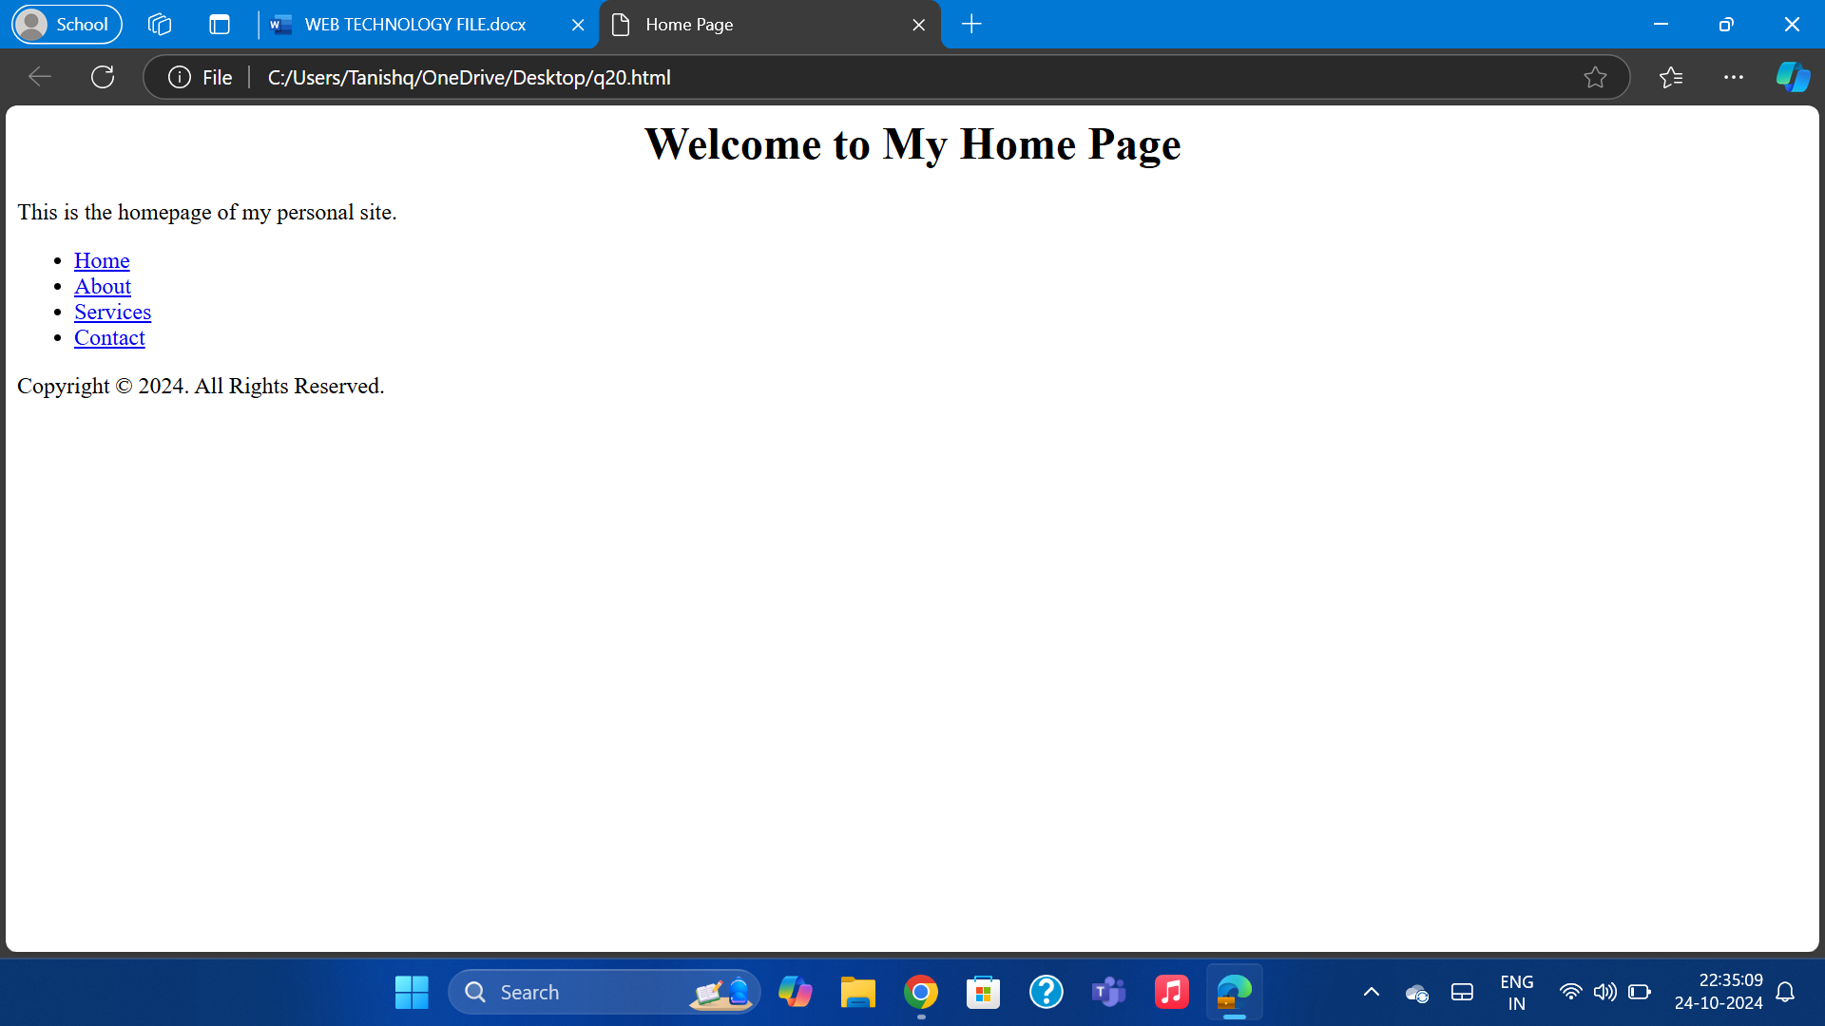

Q21 HTML code for Local Hyperlinking in a web page:

<!DOCTYPE html>

<html>

<head>

<title>Local Hyperlinking</title>

</head>

<body>

<a href="#section1">Go to Section 1</a>

<a href="#section2">Go to Section 2</a>

<h2 id="section1">Section 1</h2>

<p>This is Section 1 content.</p>

<h2 id="section2">Section 2</h2>

<p>This is Section 2 content.</p>

</body>

</html>

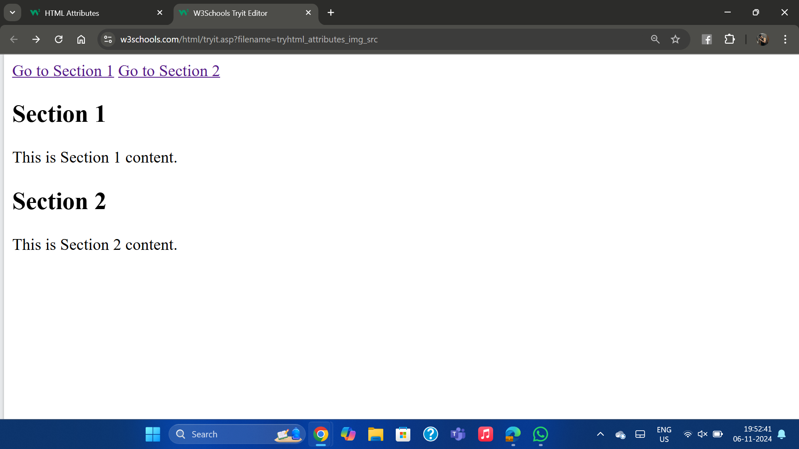

Q22 HTML code for Inter Hyperlinking in a web page

<!DOCTYPE html>

<html>

<head>

<title>Inter Hyperlinking</title>

</head>

<body>

<a href="http://www.example.com">Go to Example Website</a>

</body>

</html>

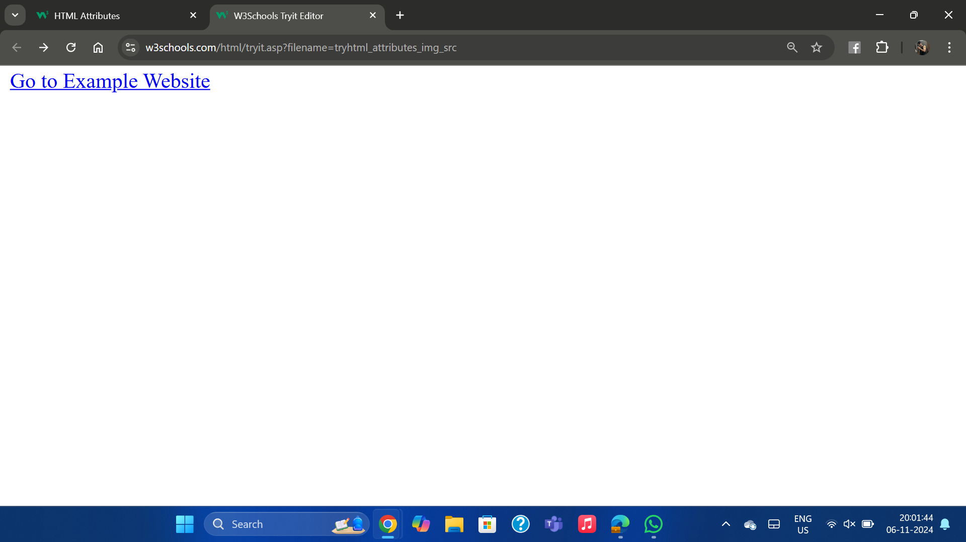

23. HTML code for External Hyperlinking in a web page:

<!DOCTYPE html>

<html>

<head>

<title>External Hyperlinking</title>

</head>

<body>

<a href="https://www.google.com" target="_blank">google</a>

</body>

</html>

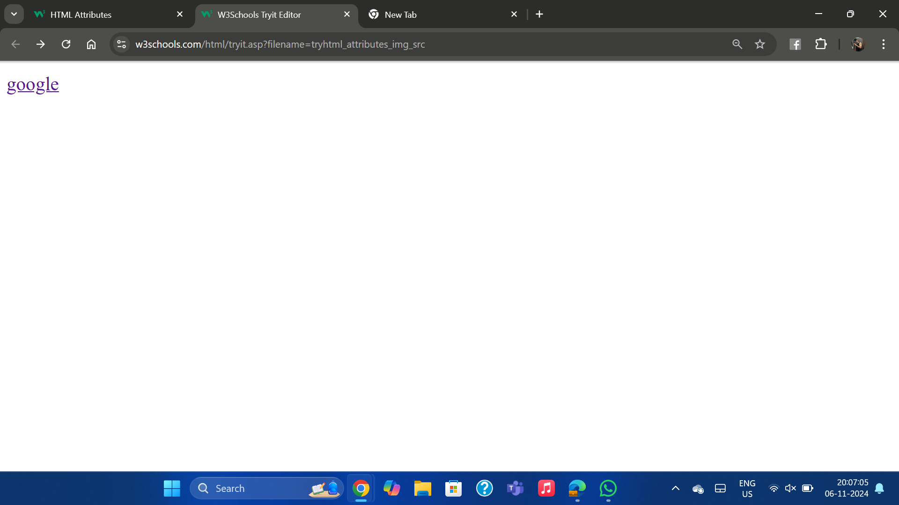

Q24 Code to show External CSS with HTML code: <!DOCTYPE html>

<html>

<head>

<title>External CSS Example</title>

<link rel="stylesheet" type="text/css" href="style.css">

</head>

<body>

<h1>Hello, World!</h1>

</body>

</html>

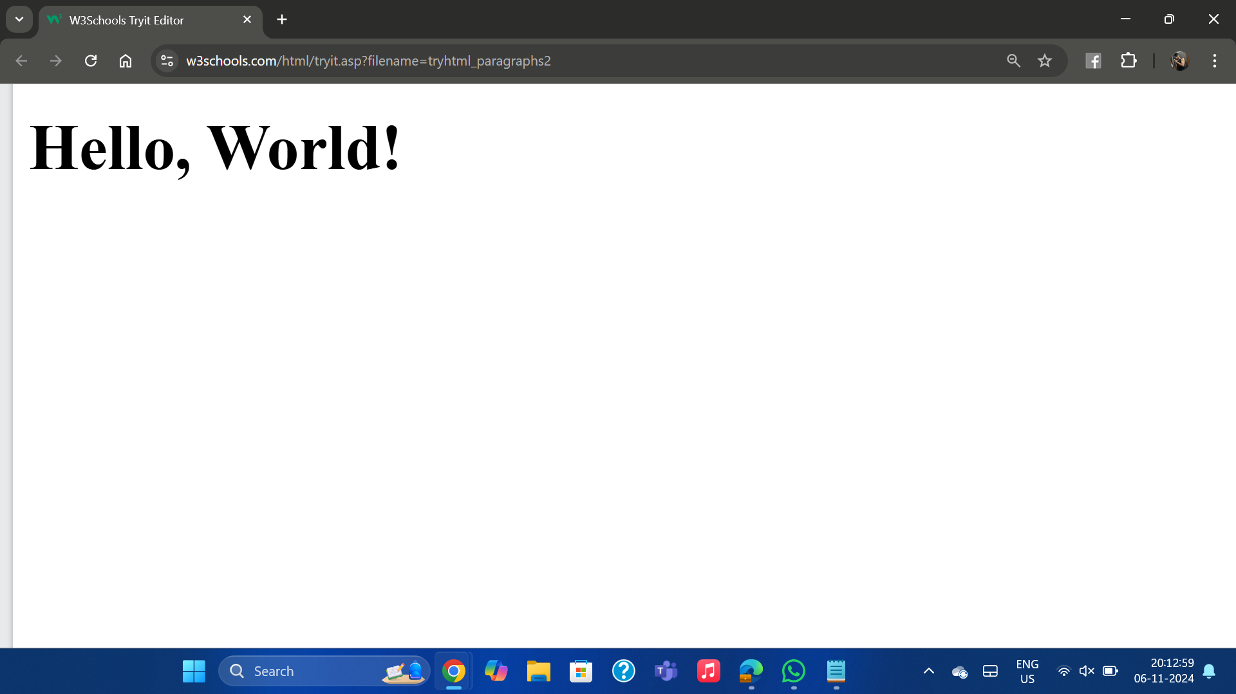

Q25 Code to show Internal CSS with HTML code:

<!DOCTYPE html>

<html>

<head>

<title>Internal CSS Example</title>

<style>

body {

background-color: lightgreen;

}

h1 {

color: darkgreen; }

</style>

</head>

<body>

<h1>Hello, World!</h1>

</body>

</html>

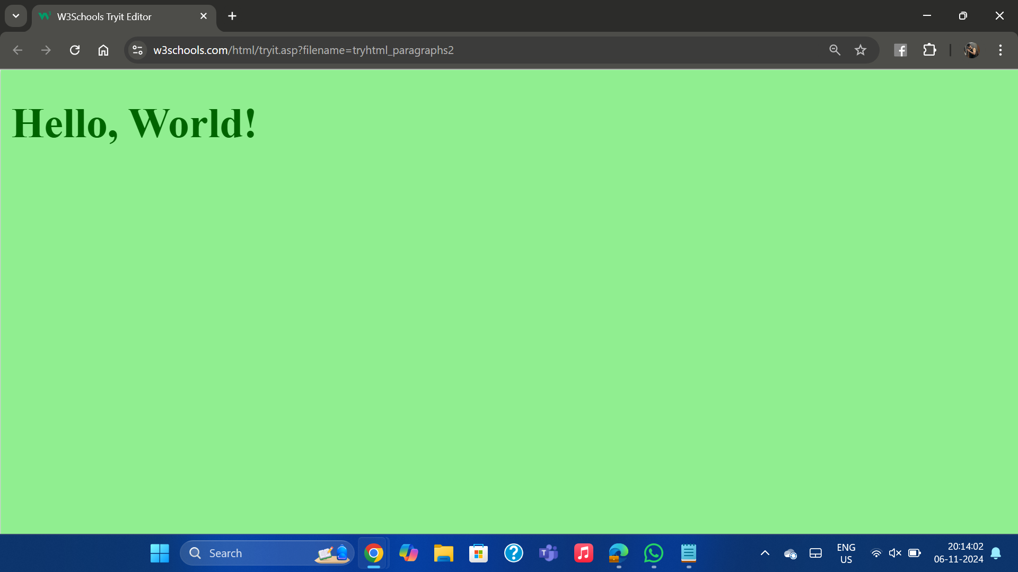

Q26 Code to show Inline CSS with HTML code:

<!DOCTYPE html>

<html>

<head>

<title>Inline CSS Example</title>

</head>

<body>

<h1 style="color: purple; background-color: yellow;">Hello, World!</h1>

</body>

</html>

